EXPERIMENT – 1
NAME – SUMANSHU JINDAL | UID – 24BCS11091
BRANCH – BE – CSE | SECTION/GROUP – 24BCS_APP-707A
SEMESTER – 5th | DATE OF PERFORMANCE – 8/9/2026
SUBJECT NAME – COMPETITIVE CODING | SUBJECT CODE – 24CSP – 305

Aim – To select at most k engineers maximizing overall team performance using greedy sorting and heaps.
Objectives
- Apply greedy methods and priority queues to optimization problems.
- Calculate maximum team performance efficiently using sorting and min-heaps.
- Analyze time and space complexity of the implemented algorithm.
- Test solutions using normal, boundary, and edge case inputs.
Theory
Engineers are sorted by efficiency in descending order. Each engineer's efficiency acts as the team's current minimum. A min-heap retains the k largest speeds, discarding the smallest when exceeded. Performance equals speed sum multiplied by current efficiency; the maximum is tracked. Time complexity is O(n log n); space is O(n).
IMPLEMENTATION/INPUT CODE
#include <iostream>
#include <vector>
#include <queue>
#include <algorithm>
using namespace std;

int maxPerformance(int n, vector<int>& speed, vector<int>& efficiency, int k) {
const int MOD = 1e9 + 7;
vector<pair<int, int>> eng(n);
for (int i = 0; i < n; ++i)
eng[i] = {efficiency[i], speed[i]};

sort(eng.rbegin(), eng.rend());

priority_queue<int, vector<int>, greater<int>> minHeap;
unsigned long long speedSum = 0, best = 0;

for (int i = 0; i < n; ++i) {
int eff = eng[i].first;
int spd = eng[i].second;

minHeap.push(spd);
speedSum += spd;

if ((int)minHeap.size() > k) {
speedSum -= minHeap.top();
minHeap.pop();
}
best = max(best, speedSum * eff);
}
return best % MOD;
}

int main() {
int n, k;
cin >> n;

vector<int> speed(n), efficiency(n);
for (int &x : speed) cin >> x;
for (int &x : efficiency) cin >> x;
cin >> k;

cout << maxPerformance(n, speed, efficiency, k) << endl;
return 0;
}
OUTPUT
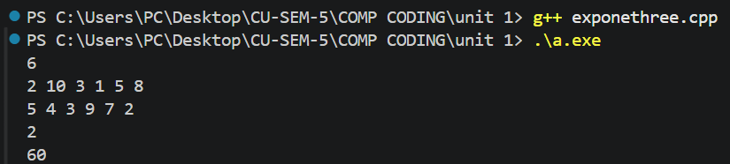
Learning Outcomes
- Understand how fixing minimum efficiency simplifies the team selection problem.
- Use min-heaps to efficiently maintain the k largest speeds dynamically.
- Prevent overflow using unsigned long long and modulo 10^9+7 correctly.
- Apply descending sorting to process engineers by decreasing efficiency order.
- Analyze time complexity O(n log n) and space O(n) accurately.
EXPERIMENT – 2
NAME – SUMANSHU JINDAL | UID – 24BCS11091
BRANCH – BE – CSE | SECTION/GROUP – 24BCS_APP-707A
SEMESTER – 5th | DATE OF PERFORMANCE – 9/9/2026
SUBJECT NAME – COMPETITIVE CODING | SUBJECT CODE – 24CSP – 305

Aim – To efficiently format an array of words into fully justified lines of exactly maxWidth characters.
Objectives
- Apply greedy line-packing and string simulation to formatting problems.
- Distribute spaces evenly between words so each line fits.
- Handle edge cases such as single-word and last lines.
- Analyze time and space complexity of the implemented algorithm.
Theory
Words are packed greedily into each line without exceeding maxWidth. The remaining spaces are distributed evenly across gaps, with extra spaces assigned to the leftmost gaps. The last line and single-word lines are left-justified, padded with trailing spaces. Time complexity is O(n) over total input characters; auxiliary space is O(maxWidth).
IMPLEMENTATION/INPUT CODE
#include <iostream>
#include <vector>
#include <string>
using namespace std;

vector<string> fullJustify(vector<string>& words, int maxWidth) {
vector<string> result;
int n = words.size(), i = 0;
while (i < n) {
int lineLen = words[i].size(), j = i + 1;
while (j < n && lineLen + 1 + (int)words[j].size() <= maxWidth)
lineLen += 1 + words[j++].size();
int numWords = j - i;
int totalSpaces = maxWidth - (lineLen - (numWords - 1));
string line;
line.reserve(maxWidth);
line += words[i];
if (numWords == 1 || j == n) {
for (int k = i + 1; k < j; ++k) {
line += ' ';
line += words[k];
}
line.append(maxWidth - line.size(), ' ');
} else {
int gaps = numWords - 1;
int spaceEach = totalSpaces / gaps;
int extra = totalSpaces % gaps;
for (int k = i + 1; k < j; ++k) {
line.append(spaceEach + (k - i <= extra ? 1 : 0), ' ');
line += words[k];
}
}
result.push_back(line);
i = j;
}
return result;
}

int main() {
int n, maxWidth;
cin >> n;
vector<string> words(n);
for (int i = 0; i < n; ++i)
cin >> words[i];
cin >> maxWidth;
vector<string> res = fullJustify(words, maxWidth);
for (int i = 0; i < (int)res.size(); ++i)
cout << "\"" << res[i] << "\"\n";
return 0;
}
OUTPUT
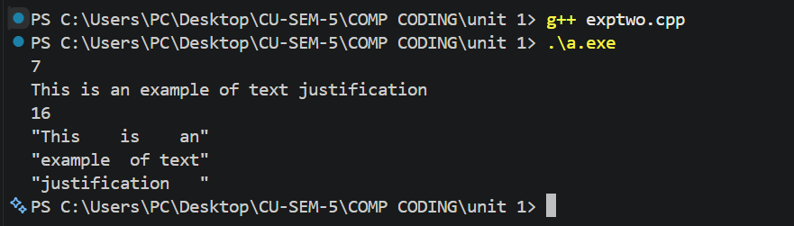

Learning Outcomes
- Understand greedy packing of words to fill each line optimally.
- Distribute remaining spaces evenly, giving extra spaces to leftmost gaps.
- Handle left-justified special cases for single-word and final lines correctly.
- Build lines efficiently using string operations without repeated unnecessary concatenation.
- Analyze time complexity O(n) and auxiliary space per output line.

EXPERIMENT – 3
NAME – SUMANSHU JINDAL | UID – 24BCS11091
BRANCH – BE – CSE | SECTION/GROUP – 24BCS_APP-707A
SEMESTER – 5th | DATE OF PERFORMANCE – 15/9/2026
SUBJECT NAME – COMPETITIVE CODING | SUBJECT CODE – 24CSP – 305

Aim – To efficiently find the minimum element in a rotated sorted array containing possible duplicate values.
Objectives
- Apply modified binary search handling rotation and duplicate elements.
- Eliminate search halves by comparing midpoint with rightmost element.
- Handle equal midpoint and rightmost values by shrinking boundary.
- Analyze time and space complexity of the implemented algorithm.
Theory
Binary search compares the midpoint with the rightmost element. If the midpoint is greater, the minimum lies right; if smaller, it lies left including midpoint. If equal, the right boundary decrements by one. The loop ends when pointers meet. Average time is O(log n), worst case O(n); space is O(1).
IMPLEMENTATION/INPUT CODE
#include <iostream>
#include <vector>
using namespace std;

int findMin(vector<int>& nums) {
int lo = 0, hi = (int)nums.size() - 1;

while (lo < hi) {
int mid = lo + (hi - lo) / 2;

if (nums[mid] > nums[hi])
lo = mid + 1; // minimum lies in right half
else if (nums[mid] < nums[hi])
hi = mid; // minimum lies in left half (with mid)
else
--hi; // equal: safely shrink right boundary
}
return nums[lo];
}

int main() {
int n;
cin >> n;

vector<int> nums(n);
for (int &x : nums)
cin >> x;

cout << findMin(nums) << endl;
return 0;
}
OUTPUT
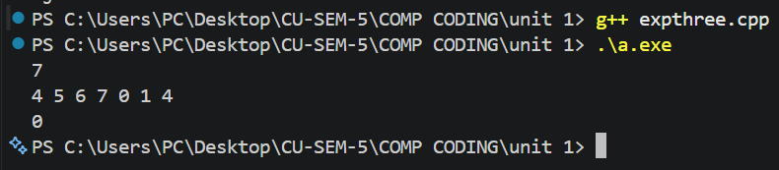
Learning Outcomes
- Understand how rotation divides a sorted array into two segments.
- Apply binary search by comparing the midpoint with the boundary.
- Resolve ambiguity caused by duplicates using safe right boundary shrinking.
- Prevent overflow by computing midpoint as lo plus half difference.
- Analyze time complexity O(log n) average and O(n) worst case.

EXPERIMENT – 4
NAME – SUMANSHU JINDAL | UID – 24BCS11091
BRANCH – BE – CSE | SECTION/GROUP – 24BCS_APP-707A
SEMESTER – 5th | DATE OF PERFORMANCE – 16/9/2026
SUBJECT NAME – COMPETITIVE CODING | SUBJECT CODE – 24CSP – 305

Aim – To create the maximum number of length k from two digit arrays preserving relative order.
Objectives
- Enumerate all valid splits of k between both arrays.
- Extract maximum subsequences using a greedy monotonic stack technique.
- Merge subsequences into largest number using lexicographic suffix comparison.
- Analyze time and space complexity of the implemented algorithm.
Theory
For each valid split of k, a monotonic stack greedily extracts the maximum subsequence from each array. The two subsequences are merged by repeatedly choosing the lexicographically greater suffix. The best merged candidate across all splits is retained as the answer. Worst-case time complexity is O(k·(m+n+k²)); auxiliary space is O(m+n).
IMPLEMENTATION/INPUT CODE
#include <iostream>
#include <vector>
#include <algorithm>
using namespace std;
vector<int> maxSubseq(const vector<int>& nums, int len) {
int drop = (int)nums.size() - len;
vector<int> st;
for (int x : nums) {
while (drop > 0 && !st.empty() && st.back() < x) {
st.pop_back();
--drop;
}
st.push_back(x);
}
st.resize(len);
return st;
}
vector<int> mergeSeq(const vector<int>& a, const vector<int>& b) {
vector<int> res;
vector<int>::const_iterator i = a.begin(), j = b.begin();
while (i != a.end() || j != b.end()) {
if (lexicographical_compare(j, b.end(), i, a.end()))
res.push_back(*i++);
else
res.push_back(*j++);
}
return res;
}
vector<int> maxNumber(vector<int>& n1, vector<int>& n2, int k) {
int m = n1.size(), n = n2.size();
vector<int> best;
for (int i = max(0, k - n); i <= min(k, m); ++i) {
vector<int> cand = mergeSeq(maxSubseq(n1, i), maxSubseq(n2, k - i));
if (cand > best) best = cand;
}
return best;
}
int main() {
int m, n, k;
cin >> m;
vector<int> nums1(m);
for (int &x : nums1) cin >> x;
cin >> n;
vector<int> nums2(n);
for (int &x : nums2) cin >> x;
cin >> k;
vector<int> res = maxNumber(nums1, nums2, k);
for (int x : res) cout << x << " ";
cout << endl;
}
OUTPUT
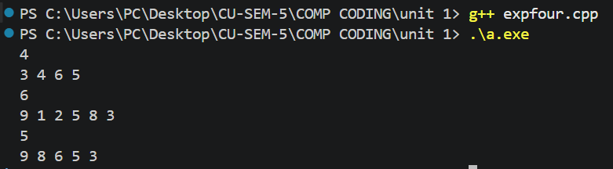

Learning Outcomes
- Understand enumerating every valid split of digits between two arrays.
- Apply monotonic stack to extract maximum subsequences of fixed length.
- Merge subsequences correctly by comparing remaining suffixes to break ties.
- Compare merged candidates lexicographically to retain the overall maximum result.
- Analyze worst-case time complexity O(k·(m+n+k²)) and auxiliary space O(m+n) accurately.

EXPERIMENT – 5
NAME – SUMANSHU JINDAL | UID – 24BCS11091
BRANCH – BE – CSE | SECTION/GROUP – 24BCS_APP-707A
SEMESTER – 5th | DATE OF PERFORMANCE – 23/9/2026
SUBJECT NAME – COMPETITIVE CODING | SUBJECT CODE – 24CSP – 305

Aim – To efficiently find the maximum value in each sliding window of size k moving rightward.
Objectives
- Use monotonic decreasing deque storing indices of useful elements.
- Remove outdated front indices that fall outside the window.
- Remove smaller back elements to maintain decreasing deque order.
- Analyze time and space complexity of the implemented algorithm.
Theory
A monotonic deque stores decreasing-value indices. For each element, smaller back values are removed and the index is pushed. Front indices outside the window are removed. Once the window is full, the front element is the maximum. Each index is pushed and popped once, giving O(n) time and O(k) space.
IMPLEMENTATION/INPUT CODE
#include <iostream>
#include <vector>
#include <deque>
using namespace std;

vector<int> maxSlidingWindow(vector<int>& nums, int k) {
vector<int> result;
int n = nums.size();
if (k <= 0 || k > n) return result;
result.reserve(n - k + 1);
deque<int> dq; // stores indices

for (int i = 0; i < n; ++i) {
if (!dq.empty() && dq.front() <= i - k)
dq.pop_front(); // index outside window

while (!dq.empty() && nums[dq.back()] <= nums[i])
dq.pop_back(); // remove smaller elements

dq.push_back(i);

if (i >= k - 1)
result.push_back(nums[dq.front()]);
}
return result;
}

int main() {
int n, k;
cin >> n;

vector<int> nums(n);
for (int &x : nums)
cin >> x;
cin >> k;

vector<int> res = maxSlidingWindow(nums, k);
for (int x : res)
cout << x << " ";
cout << endl;
return 0;
}
OUTPUT
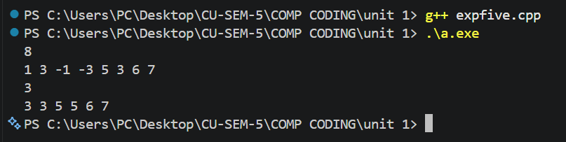
Learning Outcomes
- Understand why monotonic deques give amortized sliding window maximum queries.
- Maintain decreasing order by removing smaller elements from deque back.
- Expire outdated indices from the front using the window boundary.
- Record results only after the first full window is formed.
- Analyze time complexity O(n) and auxiliary space complexity O(k) accurately.

EXPERIMENT – 6
NAME – SUMANSHU JINDAL | UID – 24BCS11091
BRANCH – BE – CSE | SECTION/GROUP – 24BCS_APP-707A
SEMESTER – 5th | DATE OF PERFORMANCE – 30/9/2026
SUBJECT NAME – COMPETITIVE CODING | SUBJECT CODE – 24CSP – 305

Aim – To efficiently find shortest transformation sequence length between two words changing single letters each step.
Objectives
- Apply Breadth First Search (BFS) to shortest path problems.
- Generate valid one-letter transformations efficiently using hash set dictionary.
- Analyze time and space complexity of the implemented algorithm.
- Test solutions using normal, boundary, and edge case inputs.
Theory
BFS explores words level by level from the begin word. Each position is replaced by letters a-z, and valid dictionary words are queued. Visited words are erased from the set to avoid revisits. The first time the end word appears gives the shortest length. Time is O(N·L²); space is O(N·L).
IMPLEMENTATION/INPUT CODE
#include <iostream>
#include <vector>
#include <queue>
#include <string>
#include <unordered_set>
using namespace std;
int ladderLength(string beginWord, string endWord, vector<string>& wordList) {
unordered_set<string> words(wordList.begin(), wordList.end());
if (words.find(endWord) == words.end()) return 0;
queue<pair<string, int> > q;
q.push(make_pair(beginWord, 1));
words.erase(beginWord);
while (!q.empty()) {
string word = q.front().first;
int steps = q.front().second;
q.pop();
if (word == endWord) return steps;
for (size_t i = 0; i < word.size(); ++i) {
char original = word[i];
for (char ch = 'a'; ch <= 'z'; ++ch) {
word[i] = ch;
if (words.find(word) != words.end()) {
q.push(make_pair(word, steps + 1));
words.erase(word);
}
}
word[i] = original;
}
}
return 0;
}
int main() {
string beginWord, endWord;
int n;
cin >> beginWord >> endWord >> n;
vector<string> wordList(n);
for (int i = 0; i < n; ++i)
cin >> wordList[i];
cout << ladderLength(beginWord, endWord, wordList) << endl;
return 0;
}
OUTPUT
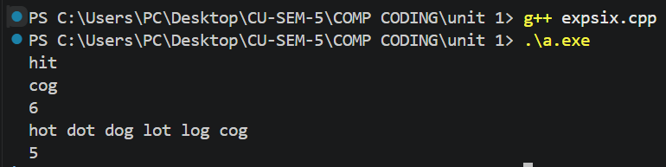
Learning Outcomes
- Understand how BFS guarantees shortest paths in implicit unweighted graphs.
- Generate neighbor words by replacing each character with every letter.
- Use unordered sets for constant-time dictionary lookups and visited tracking.
- Handle edge cases when end word is absent from dictionary.
- Analyze time complexity O(N·L²) and auxiliary space complexity O(N·L) accurately.

EXPERIMENT – 7
NAME – SUMANSHU JINDAL | UID – 24BCS11091
BRANCH – BE – CSE | SECTION/GROUP – 24BCS_APP-707A
SEMESTER – 5th | DATE OF PERFORMANCE – 6/10/2026
SUBJECT NAME – COMPETITIVE CODING | SUBJECT CODE – 24CSP – 305

Aim – To efficiently find the median of each sliding window of size k in an array.
Objectives
- Apply two-heap median maintenance using ordered multisets for balancing.
- Process sliding window insertions and deletions in logarithmic time.
- Analyze time and space complexity of the implemented algorithm.
- Test solutions using normal, boundary, and edge case inputs.
Theory
Two multisets split the window: low holds the smaller half, high the larger half. Each new element is inserted, the outgoing one erased, and sizes rebalanced. The median is the top of low for odd k, otherwise the average of both tops. Time is O(n log k); space is O(k).
IMPLEMENTATION/INPUT CODE
#include <iostream>
#include <vector>
#include <set>
#include <iterator>
#include <iomanip>
using namespace std;
vector<double> medianSlidingWindow(vector<int>& nums, int k) {
multiset<int> low, high;
vector<double> result;
int n = nums.size();
if (k <= 0 || k > n) return result;
auto balance = [&]() {
while (low.size() > high.size() + 1) {
high.insert(*low.rbegin());
low.erase(prev(low.end()));
}
while (low.size() < high.size()) {
low.insert(*high.begin());
high.erase(high.begin());
}
};
for (int i = 0; i < n; ++i) {
if (low.empty() || nums[i] <= *low.rbegin()) low.insert(nums[i]);
else high.insert(nums[i]);
balance();
if (i >= k) {
multiset<int>::iterator it = low.find(nums[i - k]);
if (it != low.end()) low.erase(it);
else high.erase(high.find(nums[i - k]));
balance();
}
if (i >= k - 1) {
if (k % 2) result.push_back(*low.rbegin());
else result.push_back(((double)*low.rbegin() + *high.begin()) / 2.0);
}
}
return result;
}
int main() {
int n, k;
cin >> n;
vector<int> nums(n);
for (int &x : nums) cin >> x;
cin >> k;
vector<double> ans = medianSlidingWindow(nums, k);
cout << fixed << setprecision(1);
for (double x : ans) cout << x << " ";
cout << endl;
return 0;
}
OUTPUT
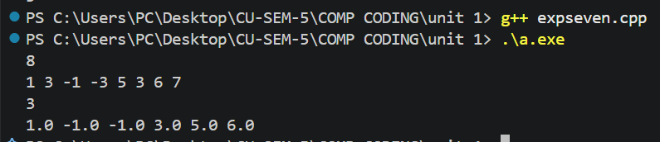
Learning Outcomes
- Understand how two balanced halves give the window median quickly.
- Insert and erase elements using ordered multisets in logarithmic time.
- Rebalance both halves after every insertion and removal operation correctly.
EXPERIMENT – 8
NAME – SUMANSHU JINDAL | UID – 24BCS11091
BRANCH – BE – CSE | SECTION/GROUP – 24BCS_APP-707A
SEMESTER – 5th | DATE OF PERFORMANCE – 7/10/2026
SUBJECT NAME – COMPETITIVE CODING | SUBJECT CODE – 24CSP – 305

Aim – To efficiently find the length of the longest valid parentheses substring in a given string.
Objectives
- Apply a stack-based approach to track unmatched parenthesis indices.
- Compute valid substring lengths using index differences from stack.
- Analyze time and space complexity of the implemented algorithm.
- Test solutions using normal, boundary, and edge case inputs.
Theory
A stack stores indices, starting with base -1. Opening brackets push index. Closing brackets pop the top; if the stack becomes empty, the current index becomes the new base. Otherwise the current index minus the top gives a valid length, and maximum is updated. Time is O(n); space is O(n).
IMPLEMENTATION/INPUT CODE
#include <iostream>
#include <stack>
#include <string>
#include <algorithm>
using namespace std;
int longestValidParentheses(const string& s) {
int maxLen = 0, n = s.size();
stack<int> st;
st.push(-1); // base index
for (int i = 0; i < n; ++i) {
if (s[i] == '(') {
st.push(i);
} else {
st.pop();
if (st.empty())
st.push(i); // new base
else
maxLen = max(maxLen, i - st.top());
}
}
return maxLen;
}
int main() {
string s;
getline(cin, s);
cout << longestValidParentheses(s) << endl;
return 0;
}
OUTPUT
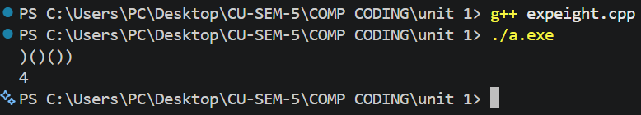
Learning Outcomes
- Understand how base index separates valid substrings from unmatched brackets.
- Use stack operations to match opening and closing parentheses correctly.
- Compute lengths directly using differences between current and top indices.
- Handle edge cases like empty strings and only closing brackets.
- Analyze time complexity O(n) and auxiliary space complexity O(n) accurately.

